**K - Means Clustering**

**Instructions:**

Please share your answers wherever applicable in-line with the word document. Submit code separately wherever applicable.

Please ensure you update all the details:

**Name: J. Berger perkins Batch ID: DSWDMCOD 281022B**

**Topic: K-Means Clustering**

**Guidelines:**

**1. An assignment submission is considered complete only when correct and executable code(s) are submitted along with the documentation explaining the method and results. Failing to submit either of those will be considered an invalid submission and will not be considered as correct submission.**

**2. Ensure that you submit your assignments correctly and in full. Resubmission is not allowed.**

**3. Post the submission you can evaluate your work by referring to keys provided. (will be available only post the submission).**

**Hints:**

**1. Business Problem**

* 1. **What is the business objective?**
  2. **Are there any constraints?**

**2. Work on each feature of the dataset to create a data dictionary as displayed in the below image:**

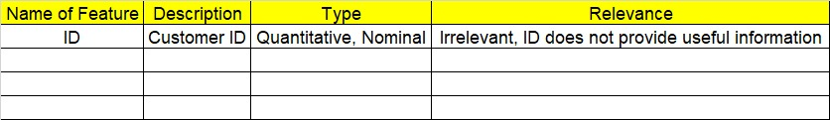

**3. Data Pre-processing**

**3.1 Data Cleaning, Feature Engineering, etc.**

**4. Exploratory Data Analysis (EDA):**

**4.1. Summary.**

**4.2. Univariate analysis.**

**4.3. Bivariate analysis.**

**5. Model Building**

**5.1 Build the model on the scaled data (try multiple options).**

**5.2 Perform K- means clustering and obtain optimum number of clusters using scree plot.**

**5.3 Validate the clusters (try with different number of clusters) – label the clusters and derive insights (compare the results from multiple approaches).**

**6. Write about the benefits/impact of the solution - in what way does the business (client) benefit from the solution provided?**

**Problem Statements:**

1. Perform K means clustering on the airline’s dataset to obtain an optimum number of clusters. Draw the inferences from the clusters obtained. Refer to EastWestAirlines.xlsx dataset.

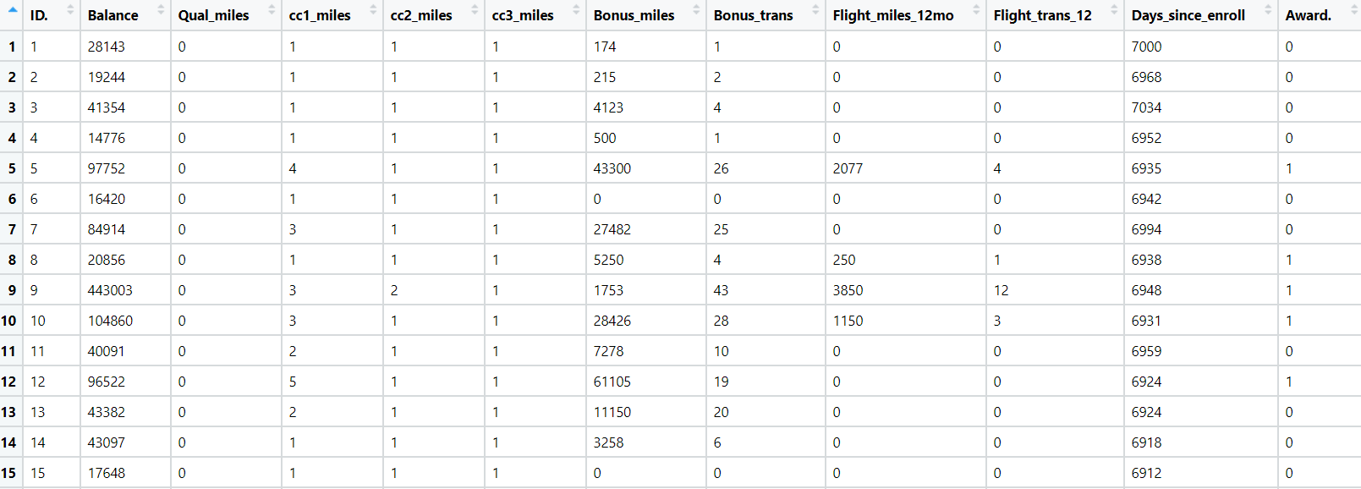

1. Perform clustering for the crime data and identify the number of clusters formed and draw inferences. Refer to the crime_data.csv dataset.

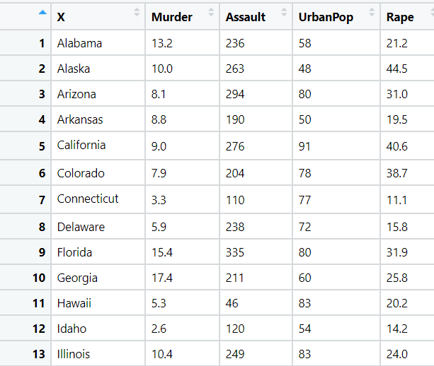

1. Perform clustering analysis on the telecom dataset. The data is a mixture of both categorical and numerical data. It consists of the number of customers who churn. Derive insights and get possible information on factors that may affect the churn decision. Refer to Telco_customer_churn.xlsx dataset.

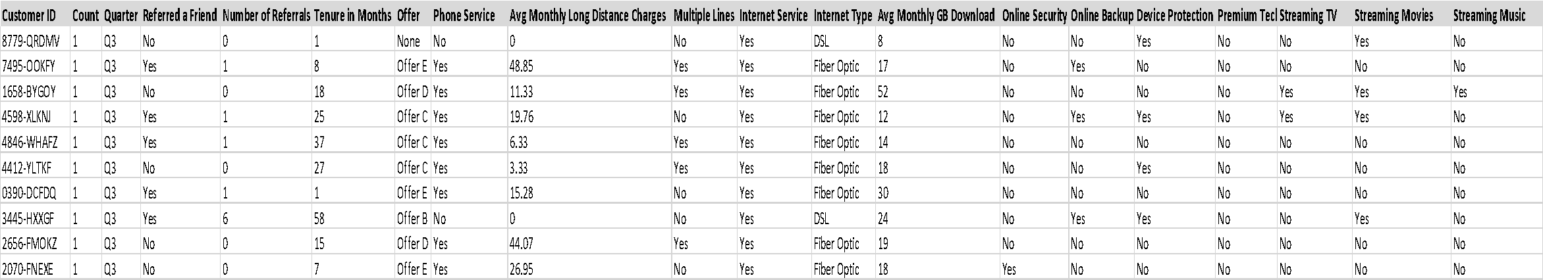

1. Perform clustering on mixed data. Convert the categorical variables to numeric by using dummies or label encoding and perform normalization techniques. The dataset has the details of customers related to their auto insurance. Refer to Autoinsurance.csv dataset.

